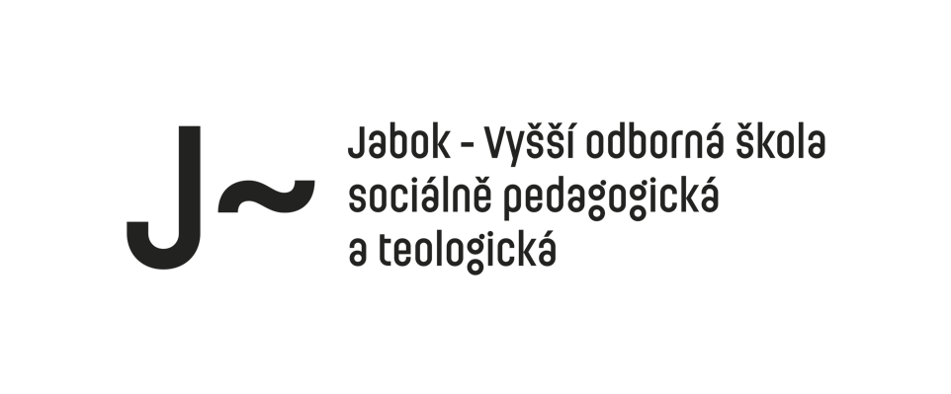

**Teologie a symbol**

**Odkaz na ZOOM:**

[**https://cuni-cz.zoom.us/j/93945031555**](https://cuni-cz.zoom.us/j/93945031555)

sirka@jabok.cz Salmovská 8, Praha 2, 120 00 www.jabok.cz