Unit 13 Rehabilitation of People with Disabilities

13.1 Leading in
Brainstorming. Do you know any famous people who had some kind of disability? How did the disability influence their lives? Were they able to work?

13.2 Listening
- Watch the short film Famous People with Disabilities and check the brainstorming results from 13.1.
https://www.youtube.com/watch?v=GGCnhCXSQBg

- Do you know why the people from the film are famous? Do you remember which disabilities they suffered from?

13.3 Reading and Speaking

Divide into two groups. Each group will read 7 quotes and match them with names and pictures of famous people. Then introduce your famous people and their quotes to the other group.

Group 1
Person | Quote
Leonardo da Vinci | If you can´t explain it simply, you do not understand it well enough.
Charles Darwin | Time you enjoy wasting was not wasted.
David Beckham | The painter has the Universe in his mind and hands.
Albert Einstein | Walking with a friend in the dark is better than walking alone in the light.
George Washington | An American monkey, after getting drunk on brandy, would never touch it again, and thus is much wiser than most men.
John Lennon | I have got this obsessive compulsive disorder where I have to have everything in a straight line, or everything has to be in pairs.
Helen Keller | If the freedom of speech is taken away then dumb and silent we may be led, like sheep to the slaughter.

Group 2
Person | Quote
Michelangelo Buonarotti | I'm not the smartest fellow in the world, but I can sure pick smart colleagues.
Cameron Diaz | To every action there is always opposed an equal reaction.
Leonardo DiCaprio | The true work of art is but a shadow of the divine perfection.
Isaac Newton | An actress can only play a woman. I'm an actor, I can play anything.
F.D. Rooswelt | I like to be able to play a character and act out a lot of things which I can't or don't do in my normal everyday life.
Ludwig van Beethowen | Whenever I don't' have to wear makeup, it's a good day.
Whoopi Goldberg | Only the pure in heart can make a good soup.

13.4 Listening
Listen to the article and fill in the gaps.
Well Known People with Disabilities
Have a disability or ……………………………….. condition? You are not alone. Many people with disabilities have contributed to ………………………………... These include actors, ……………………………….., celebrities, singers, world leaders, and many other famous people. Of course there are also millions of people ……………………………….. who may not be famous in the sense society ………………………………..famous, but still live with, battle, and overcome their disabilities every single day ……………………………….. their lives.
A disability is often used to ……………………………….. to individual functioning, including physical impairment, ……………………………….. impairment, cognitive impairment, intellectual impairment, mental illness, and various types of ……………………………….. diseases.
http://www.disabled-world.com/artman/publish/article_0060.shtml#sthash.07nKPpIV.dpuf

13.5 Reading
Read together the introduction. Then divide into 6 groups, fill in the gaps with the given words, read the part of your text and refer then to the whole class about your part.
Introduction: Types of Disabilities
Types of disabilities include various physical and mental impairments that can hamper or reduce a person's ability to carry out his day to day activities. These impairments can be termed as disability of the person to do his or her day to day activities. "Disability" can be broken down into a number of broad sub-categories, which include the following:
- Mobility and Physical Impairments
organs, fall, includes, of, dexterity, including, Lower, acquired
This category of disability …………………………… people with varying types of physical disabilities ……………………………:
- Upper limb(s) disability
- …………………………… limb(s) disability
- Manual ……………………………
- Disability in co-ordination with different …………………………… of the body
Disability in mobility can be either an in-born or …………………………… with age problem. It could also be the effect …………………………… a disease. People who have a broken bone also …………………………… into this category of disability.
- Spinal Cord Disability:
birth, due, injury, lifelong, apparent, conveyed, complete, organs
Spinal cord …………………………… can sometimes lead to …………………………… disabilities. This kind of injury mostly occurs …………………………… to severe accidents. The injury can be either …………………………… or incomplete. In an incomplete injury, the messages …………………………… by the spinal cord are not completely lost, whereas a complete injury results in a total dis-functioning of the sensory ……………………………. In some cases spinal cord disability can be a …………………………… defect.
c) Invisible Disabilities
Invisible Disabilities are disabilities that are not immediately …………………………… to others. It is estimated that 10% of people in the U.S. have a medical condition considered a type of invisible disability.

- Head Injuries - Brain Disability
mild, occurs, hereditary, magnitude, forces, in, disturbance, cases
A disability in the brain …………………………… due to a brain injury. The ……………………………of the brain injury can range from ……………………………, moderate and severe. There are two types of brain injuries:
- Acquired Brain Injury (ABI)
- Traumatic Brain Injury (TBI)
ABI is not a …………………………… type defect but is the degeneration that occurs after birth.
The causes of such …………………………… of injury are many and are mainly because of external …………………………… applied to the body parts. TBI results …………………………… emotional dysfunctioning and behavioural …………………………….
- Vision Disability
from, blindness, speech, suffering, hundreds, result, kind, various
There are …………………………… of thousands of people that suffer …………………………… minor to various serious vision disability or impairments. These injuries can also …………………………… into some serious problems or diseases like …………………………….
f) Cognitive or Learning Disabilites
Cognitive Disabilities are …………………………… of impairment present in people who are …………………………… from dyslexia and …………………………… other learning difficulties and includes …………………………… disorders.
g) Hearing Disability
misconception, partially, auditory, oral, include, correct, sign, later
Hearing disabilities …………………………… people that are completely or partially deaf, (Deaf is the politically …………………………… term for a person with hearing impairment).
People who are …………………………… deaf can often use hearing aids to assist their hearing. Deafness can be evident at birth or occur …………………………… in life from several biologic causes, for example Meningitis can damage the …………………………… nerve.
Deaf people use …………………………… language as a means of communication. Hundreds of sign languages are in use around the world. In linguistic terms, sign languages are as rich and complex as any …………………………… language, despite the common …………………………… that they are not "real languages".

h) Psychological Disorders
day-to-day, problems, mood, sufficient, describe, characterized, as, behaviour
Affective Disorders: Disorders of …………………………… or feeling states either short or long term. Mental Health Impairment is the term used to …………………………… people who have experienced psychiatric …………………………… or illness such as:
- Personality Disorders - Defined …………………………… deeply inadequate patterns of …………………………… and thought of …………………………… severity to cause significant impairment to …………………………… activities.
- Schizophrenia: A mental disorder …………………………… by disturbances of thinking, mood, and behaviour.
www.disabled-world.com
Vocabulary:
apparent (adj) | zřejmý
convey (v) | dopravit, sdělit
cord (n) spinal cord | mícha
deaf (adj) | hluchý
dexterity (n) | zručnost, šikovnost
disturbance (n) | nepokoj, porucha
hamper (v) | překážet, bránit
hereditary (adj) | dědičný
injury (n) | poranění
limb (n) | končetina
magnitude (n) | velikost, závažnost
oral (adj) | mluvený, ústní
pattern (n) | vzorec
suffer (v) from | trpět
severity (n) | vážnost
sufficient (adj) | dostatečný
13.6 Speaking and Writing
Think about your meeting with a person with impairment. Then tell your story to your partner or write it down.
13.7 Listening

Watch the short film Supported Living. As pre-listening activity translate the following collocations and phrases and try to think of what is their connection to the topic Supported Living.
support worker
independent lives
to offer personal services
learning disability
to be focused on helping people
to provide care and support
to make choices
https://www.youtube.com/watch?v=DMqLuj87Rv4

Watch the second film Work. Try to catch as many of collocations or phrases as you can. Write them down into the table and translate them.
https://www.youtube.com/watch?v=uv5O7FJmtH4

13.8 Reading
Read the following article to learn what options at work people with disabilities can have.

Options at work
The onset or progression of a disability can be a devastating event. However, it does not always mean that you will have to give up your job. Employers are obliged to make reasonable accommodations for staff with disabilities and often, you can continue working in an adapted workplace or with equipment and changes to your work practice and conditions of employment. Some possible options for you and your employer include:
- Partial re-deployment which allows you to continue to do part of your original job (either part-time or with the addition of new tasks). You can drop certain tasks and take on others that are currently carried out by other colleagues.
- Re-deployment: If you are unable to perform your previous job, but could carry out another function within the organisation, re-training and re-deployment are options you and your employer can consider.
- Flexible working arrangements: If you have a disability, being able to work part-time, flexitime, job share or work from home may be a deciding factor in whether you can resume your working life.
- Adapting the workplace and assistive technology: an accessible workplace and assistive technology can allow you to perform your job without difficulty. The Workplace/Equipment Adaptation Grant provides funding towards the costs of modifications or special equipment that will allow a disabled person to take up an offer of employment or to remain in employment.
- Personal Reader Grant: If you are blind or visually impaired and you need help with job-related reading, you may be entitled to a grant to allow you to employ a personal reader.
- Sheltered workshops: Sheltered work gives people with disabilities the opportunity to take part in daily work in a sheltered setting where they receive personal support services. Trainees may produce goods that have a commercial value.
- Rehabilitative training: It is provided in accredited training centres run by Health and Safety Executive or by service providers contracted by HSE.
http://www.citizensinformation.ie/en/employment/employment_and_disability/working_with_a_disability.html

Vocabulary
carry out (v) | provádět, vykonat
consider (v) something | uvažovat
currently (adv) | v současné době
deployment (n) | přerozdělení, rozmístění
drop (v) something | nechat čeho
entitle (v) | opravňovat
impaired (adj) visually impaired | zrakově postižený
perform (v) | vykonávat, provádět
previous (adj) | předchozí
onset (n) | začátek
option (n) | volba
original (adj) | původní
reasonable (adj) | rozumný, slušný
resume (v) something | pokračovat
take on (v) something | nabrat si, přijmout
take up (v) something | začít se věnovat, přijmout
workshop (n) sheltered workshop | chráněná dílna

13.9 Ideas for Homework

Search the Internet and find some kinds of assistive technologies. Prepare a short presentation on them.

13.10 Listening and writing

Watch the video from the Texas Department of Assistive and Rehabilitative Services about vocational rehabilitation process or read some article from their webpages and write a short report about their work.
http://www.dars.state.tx.us/drs/vr.shtml

13.11 Speaking
Have you ever been to any sheltered workshop? Tell your schoolmates about it. Then look at the pictures and describe them.
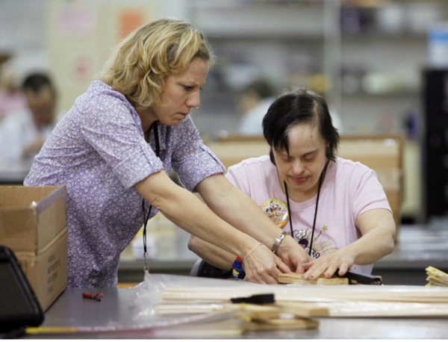
http://www.dispatch.com/content/stories/local/2012/04/03/workshops-still-get-most-federal-funds-for-disabled.html
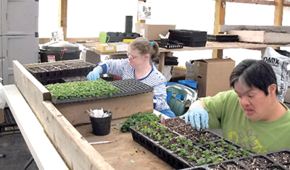
http://www.moworkshops.org/About/Consumers.html
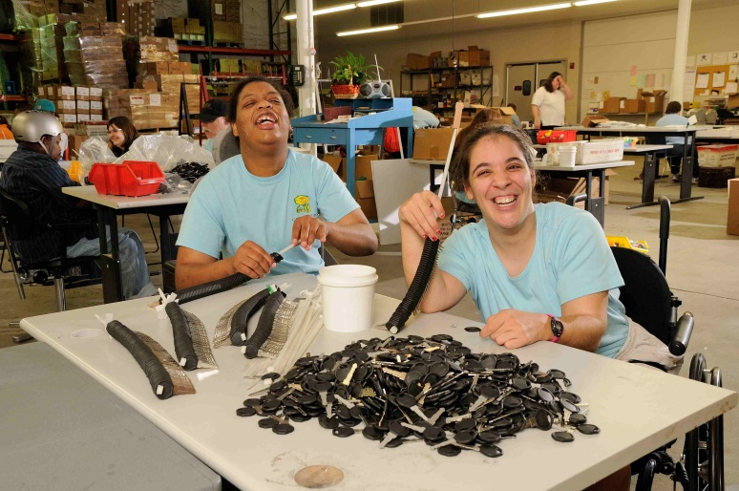
http://www.canterburyinc.org/about-sheltered-workshops/
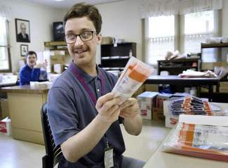
http://prev.dailyherald.com/story/?id=290001

13.12 Follow up
Do you know this man? He said, "It is a waste of time to be angry about my disability. One has to get on with life and I haven't done badly. People won't have time for you if you are always angry or complaining."

http://greatmindsoftheworld.com/stephen-hawking/

Read about his life story on the Internet for example:

http://www.disabled-world.com/disability/disability-quotes.php#sthash.ee1XDihN.dpuf

