3 SHELTERED HOUSING
3.1 Lead-in
Match the photographs:
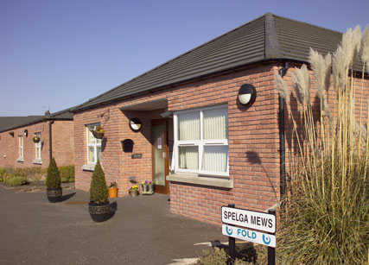
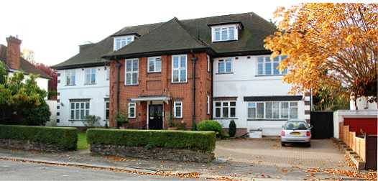
In which house would you like to live in case you are old or you have some kind of impairment? What are advantages or disadvantages of these three places of living? Discuss with your partner or in a group.
3.2 Reading:
Sheltered housing is one of the main housing options for vulnerable people who can be divided into the following groups:
- former rough sleepers
- people with mental health problems
- people with a physical or sensory disability
- people with learning disabilities
- people with mental disabilities
- seniors
- street children
- care leavers
- victims of domestic violence, trauma or sexual abuse
- young mothers or families
There are many different types of sheltered housing schemes. Some will have a scheme manager (a warden) who lives onsite or offsite, and all should provide 24-hour emergency help through an alarm system. Sheltered housing can offer a range of services to help people live independently as much as possible.
Sheltered housing schemes are often run by local councils. There is sometimes a waiting list for sheltered housing.
Each scheme usually has between 20 and 40 self-contained flats or bungalows, but there will often be communal areas, such as the lounge, laundry room and garden. Many schemes run social events for residents.
People can rent or buy sheltered housing.
Some schemes are designed specifically for disabled people and may have specialised facilities and specially trained staff to provide support. If people need more support, extra-care sheltered housing may be available. This allows more independence than living in a care home, as residents would still live in a self-contained flat but would have their meals provided and may also receive personal care.
The system of sheltered housing is closely related to de-institutialization which is a process when people are released from institutional care (e.g. big care homes or psychiatric hospital) to care in separate houses or flats.
http://www.ageuk.org.uk/home-and-care/housing-choices/sheltered-housing/

Vocabulary:
council (n), local council | /ˈləʊk(ə)l ˈkaʊns(ə)l/ | místní úřad
disability (n), learning disability | /ˈlɜː(r)nɪŋ ˌdɪsəˈbɪləti/ | poruchy učení, týká se i lidí s mentálním postižením
divide (v) into, between, from | /dɪˈvaɪd/ | rozdělit
housing (n), sheltered housing | /ˈʃeltə(r)d ˈhaʊzɪŋ/ | chráněné bydlení
list (n), waiting list | /ˈweɪtɪŋ ˌlɪst/ | čekací listina
offer (v) someone something or something to someone | /ˈɒfə(r)/ | nabídnout
option (n) | /ˈɒpʃ(ə)n/ | volba, alternativa
provide (v) | /prəˈvaɪd/ | provádět, poskytovat, zajišťovat
range (n) | /reɪndʒ/ | škála, řada
sensory (adj) | /ˈsensəri/ | smyslový
sleeper (n), rough sleeper | /rʌf ˈsliːpə(r)/ | člověk spící pod širým nebem
vulnerable (adj) | /ˈvʌln(ə)rəb(ə)l/ | zranitelný, bezbranný
warden (n) | /ˈwɔː(r)d(ə)n/ | zodpovědná osoba, správce, dozorce

3.3 Use of English

Try to think of definitions of these words in the Vocabulary. Use relative clauses. Mind the part of speech (word class) of words explained.

3.4 Use of English

Fill in the crossword:
Across
1. an organization that provides local government in a city, county, area etc.
5. to give someone something that they want or need
6. a group of houses or flats for people who cannot live in a completely independent way
7. a list of people waiting for something that may become available, for example a service or a place in a school
8. relating to the senses of sight, hearing, smell, taste, and touch
9. able to be easily physically, or mentally hurt, influenced, or attacked
10. someone who sleeps or lives outside because they have no home
11. something that you can choose in a particular situation
Down
2. a condition that prevents someone from learning basic skills or information at the same rate as other people
3. someone whose job is to be responsible for a particular place or thing, and who checks that rules are obeyed
4. to let someone know that you will give them something if they want it
3.5 Use of English
Finish the sentences:
If I were a single parent and lost my job, I would....................
If I left a children´s home when I was 18, I would....................................
If my partner destroyed all my belongings .....................................
If I were 85 and my children lived in another country ..............................
If my son had Down´s syndrome and was 25 .....................................
3.6 Reading:
Read the interview and after that answer the two multiple-choice questions:
1 The purpose of the text is to
A describe life in homeless shelter housing
B help find the purpose of life for social workers
C show how to share a social worker´s job with their own children
D inform the reader about the critical situation of children in shelters

2 Rachel Collins works now as
A a field social worker and a volunteer at a soup kitchen
B a pastoral worker in a local church
C a Project Coordinator at the National Centre on Family Homelessness
D a Project Coordinator and a part-time social worker at a local shelter

MOMMY, WHY DON´T THESE KIDS HAVE HOMES? TALKING TO YOUR KIDS ABOUT YOUR JOB
Katherine Potter caught up with Rachel Collins of the National Centre on Family Homelessness.
KP: How you would describe your work?
RC: I have worked for many years in women’s shelters, trying to help women and families get back on their feet. These women have experienced domestic violence, sexual abuse, mental illness, trauma, and substance abuse. I try to support women to become successful parents, to educate them and help them overcome barriers.
I feel that this is my purpose in life, it’s my passion. I just hope to make even a small difference. I work now as a Project Coordinator at the National Centre on Family Homelessness, and still work part-time at a local shelter.
KP: And you’re a mom yourself. How has your work affected your son?
RC: Well, my son Moira is 16 years old now. When he was younger, sometimes he would get upset if I was on call and had to leave him at night to deal with a problem at the shelter. But he knew that I could always come home if he really needed me.
KP: That sounds tough. How would you explain your job to him?
RC: I would try to tell him that this is my purpose in life, to help these women. I would also tell him that he was very fortunate to have a place to sleep at night, and that there were lots of kids who had to sleep at shelters. I would ask him to think about how he would feel if he were in their shoes.
KP: How did you explain homelessness to him?
RC: I brought him with me to the shelter when he was about six years old, so he was exposed to the realities of homelessness at an early age. It was important for him to understand that these kids are not any different than he is. He made some friends at the shelter when he was very young, and he still keeps in contact with them today.
Moira would always ask why some kids didn’t get to have homes. I explained to him that it was not because of anything bad that they or their parents had done. I would talk with him about how when people live in poverty, there are so many factors that can lead them to becoming homeless. I wanted him to know the truth when he heard others talking about people experiencing homelessness in stereotypical ways.
KP: How do you think this kind of exposure affected him growing up?
RC: In a positive way. When he tells kids at school what I do for work, some of them will share that they have spent time in a homeless shelter. That’s a hard thing for a kid to talk about. He knows that it’s important to help others. He volunteers through our church at elderly homes and soup kitchens.
KP: What do you recommend to other homeless service providers who are parents?
RC: I encourage people to teach their kids about the realities of homelessness and poverty. Kids may see the world as unfair, but if they understand what’s going on, they might be inspired to do something about it.
http://homeless.samhsa.gov/Resource/Mommy-Why-Don%E2%80%99t-These-Kids-Have-Homes-33045.aspx
Vocabulary:
abuse (n), sexual abuse | /ˈsekʃuəl əˈbjuːs/ | sexuální zneužívání
abuse (n), substance abuse | /ˈsʌbstəns əˈbjuːs/ | zneužívání návykových látek
become,became,become (v) | /bɪˈkʌm, bɪˈkeɪm/ | stát se
deal,dealt,dealt (v) | /diːl, delt/ | prodávat a kupovat ilegálně drogy
deal,dealt,dealt (v) with | /diːl, delt/ | zabývat se čím
encourage (v) someone to do something | /ɪnˈkʌrɪdʒ/ | povzbudit, podporovat někoho, aby něco dělal
explain sth to sb | /ɪkˈspleɪn/ | vysvětlit něco někomu
expose (v) | /ɪkˈspəʊz/ | vystavit
grow, grew, grown up (v) | /ɡrəʊ ʌp/ | vyrůst, dospět
home (n), elderly home | /ˈeldə(r)li həʊm/ | domov pro seniory
passion (n) | /ˈpæʃ(ə)n/ | vášeň
poverty (n) | /ˈpɒvə(r)ti/ | chudoba
purpose (n) | /ˈpɜː(r)pəs/ | účel, smysl, cíl
share (v) sth with sb | /ʃeə(r)/ | sdílet se, rozdělit se o něco s někým
upset (adj), get upset | /get ʌpˈset/ | rozčílit se, naštvat se
violence (n), domestic violence | /dəˈmestɪk ˈvaɪələns/ | domácí násilí
3.7 Use of English
Connect the phrases, phrasal verbs and collocations from the text above, explain them in English and find the equivalent in Czech:
a get back 1 violence
b domestic 2 home
c deal 3 upset
d to be 4 up
e elderly 5 in their shoes
f soup 6 with problems
g grow 7 on their feet
h get 8 kitchen

Complete the sentences with the given phrases:
1 The local council provides more refuges for women escaping ………………………..
2 He even ate at the .................................. to save money and time.
3 I am sorry for them. They have lost their home. I wouldn´t like ....................................
4 For the last year Archie, under doctor's orders has been unable to work, but hopes ……………………….within a few following operations.
5 I ........................... when he said to me ‘Don't ..............................´.
6 I'll never be .............................. if I keep forgetting things.
7 This booklet gives you guidance on how .......................................... in the workplace.
8 The 85-and-older population is expected to more than triple between 2008 and 2050 in the United States alone. This statistic proves the growing need for ....................................
3.8 Speaking
Topic for discussion:
What stereotypical ways are people experiencing homelessness?
How can a parent´s job positively influence children? And negatively? Find some examples from your life.
Look at the picture. Who is, in your opinion, a member of a staff and who is a client of a centre for homeless people? Why?
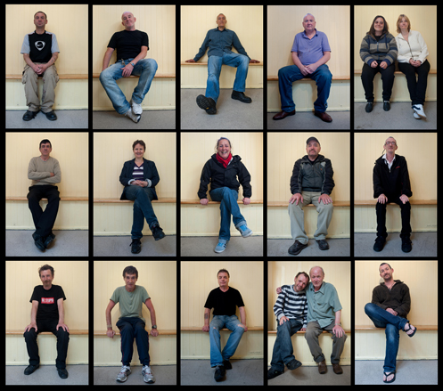
3.9 Use of English
Find sentences in the text 3.6 where the word WOULD is used to express past tense.
3.10 Listening
Watch the video about a homeless man, Lonnie, and answer the questions:
1/ Why did Lonnie move from Georgia to Florida?
2/ What could the word panhandle mean?
3/ How would you translate to be temporarily unemployed?
4/ What is another possibility for the collocation to sleep rough?
5/ Where does Lonnie sleep?
6/ Why not in the park?
7/ Who is the biggest threat for him?
8/ How does he get food?
9/ Why did he become homeless?
10/ Translate: Nevycházíme spolu.
https://www.youtube.com/watch?v=f4NFfpkgUdg
3.11 Advanced Reading:
Sheltered Housing for Homeless people.
Current research indicates that service provision should be focused on the eventual re-settlement of homeless people. Care and support options are viewed as a continuum responding to people's different needs but are critically dependent on the availability of a variety of accommodation models as described below in the Figure. Ultimately, access to permanent housing is the most important of these provisions, as people will not progress through the various systems without it. The key difficulty in tackling homelessness is the scarcity of more appropriate accommodation which includes:

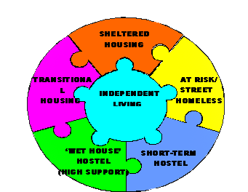
- Sheltered Housing for the Elderly, for Persons with Mental Health problems, for Persons with Disabilities
- Foyer Accommodation for young persons leaving care or at risk of becoming homeless
- Transitional housing / Half Way Houses / 'Move On' Accommodation for people coming from After Treatment Programmes, High Support Hostels, Emergency Accommodation
- High Support Hostel for persons with acute addiction problems
- Emergency Accommodation / Hostels where they are not available
(Transitional housing programs provide temporary residence—up to 24 months—for people experiencing homelessness. Housing is combined with wrap-around services to assist the individual with developing stability in their lives.)
Research indicates that Homeless men and women do not have different illnesses than the general population but their living conditions, their poverty and the complex nature of their lives affect their ability to cope with health problems and with any other problems as well.
3.12 Speaking:
Discuss in groups of three or four: Do you know of any sheltered housing in your neighbourhood? Have you ever visited any sheltered housing? What is your experience?
3.13 Writing:
Write an essay about pros and cons of institutional care.
3.14 Follow up:
1) In groups of three or four create a poster where you will compare the differences of your lives and lives of homeless people in sheltered housing. Be as creative as you want to be. Then put your poster on a wall and read your classmates´ posters. When finished, ask questions about the posters of other groups.
2) Think of the picture. Do you agree with the statement? Give some reasons.

